FUNCTIONAL REQUIREMENTS:
- As a patient, I want to register an account, so I can book my appointments.
- As a patient, I want to log in to my account, so I can access my personal appointment dashboard.
- As a patient, I want to book a new appointment with a preferred doctor, so I can receive medical consultation.
- As a patient, I want to view and cancel my appointment, so that I can book it another time.
- As a patient, I want to receive notifications, so that I don’t miss important updates and can manage my care effectively.
- As a doctor, I want to log in to my account, so I can view my appointments.
- As a doctor, I want to view my daily schedule, so I can prepare for my consultations.
- As a doctor, I want to update my appointment, so I can mark it as completed.
- As a doctor, I want to cancel my appointment, so that my schedule can be updated promptly and the patient’s time can be respected promptly.
- As a doctor, I want to receive notifications about new or updated appointments, so I can respond promptly.
- As a staff member, I want to log in to the system, so I can manage clinic appointments.
- As a staff member, I want to view the overall appointment schedule for all doctors, so I can check available slots.
- As a staff member, I want to assign and reassign appointments to doctors, so I can balance the workload.
- As a staff member, I want to send manual notifications to patients and doctors, so I can communicate important updates.
- As a staff member, I want to generate basic schedule reports so I can support administrative decisions.
NON-FUNCTIONAL REQUIREMENTS:
- The system must use secure authentication and authorization mechanisms to protect user data.
- The system is required to store and manage data using database-based storage solutions.

USE CASE DIAGRAM

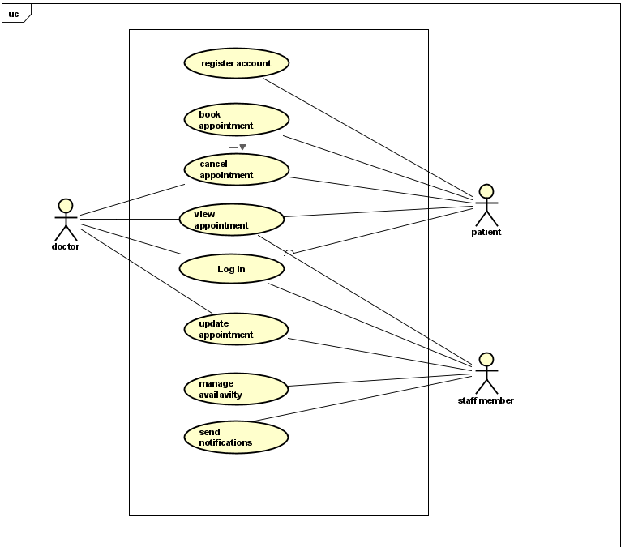

USE CASE DESCRIPTIONS
Book Appointment.
Use Case | Book Appointment
Summary | To allow a registered patient to schedule appointments.
Actor | Patient
Pre-condition | The patient must be logged into their account.
Post-condition | A new appointment has been confirmed and added to the system.
Main Scenario | - The patients select “book appointment”.  - The system displays available doctors and time slots.  - The patient chooses a doctor and prefers time.  - The system checks for scheduling conflicts.  - The patient confirms the appointment details.  - The system creates the appointment and sends a confirmation notification.
Alternate Scenario | [ALT 3] If the patient exits without confirming, no appointment is booked.
Note | This use case covers functional requirements 1, 2, 3 and Non-functional 1,2.

Manage Appointments.
Use Case | Manage Appointments
Summary | To allow staff members to view, assign, and reassign patient appointments among doctors.
Actor | Staff Member
Pre-condition | The staff member must be logged into the system.
Post-condition | Appointments may be updated, assigned, or reassigned to doctors as needed.
Main Scenario | - The staff member selects “Manage Appointments”.  - The system displays the full appointment schedule for all doctors.  - The staff member selects an appointment to modify.  - The system displays appointment details and doctor availability.  - The staff member assigns or reassigns the appointment to a doctor.  - The system updates the appointment record.  - The system sends notifications to the affected doctor and patient.
Alternate Scenario | [ALT 5] If no doctor is available for the selected time slot, the system informs the staff member, and the appointment cannot be assigned or reassigned.
Note | This use case covers functional requirements 8,9,10,11,12 and non-functional requirements 1,2.

Manage Availability.
Use Case | Manage Availability
Summary | To allow staff members to update doctors’ schedules, available time slots, and clinic availability.
Actor | Staff member
Pre-condition | The staff member must be logged into the system.
Post-condition | A doctor’s availability is updated in the system.
Main Scenario | - The staff member selects “Manage Availability”.  - The system displays the availability calendar for all doctors.  - The staff member selects a doctor’s schedule to update.  - The system shows the doctor’s current available and unavailable time slots.  - The staff member adds, edits, or removes availability slots.  - The staff member confirms the changes.  - The system saves the updated availability and refreshes the schedule.
Alternate Scenario | [ALT 4] If the staff member enters an invalid time, the system displays an error and does not apply the update.
Note | This case covers functional requirements 9, 10. Non-functional 1,2.

Update Appointment.
Use Case | Update appointment.
Summary | To allow doctors to update the status of their appointments, including marking them as completed.
Actor | Doctor
Pre-condition | The doctor must be logged into their account.
Post-condition | The appointment record is updated and saved in the system.
Main Scenario | - The doctor selects “update appointments”.  - The system shows all appointments for the selected day.  - The doctor selects an appointment to update.  - The system shows the details of the selected appointment.  - The doctor updates the appointment status (e.g., marks as completed, In Progress) or adds notes.  - The system saves updated appointment information.
Alternate Scenario | [ALT 5] If the doctor enters invalid information, the system displays an error and asks the doctor to correct it.
Note | This use case covers functional requirements 5,6,7. Non-functional 1,2.

Activity Diagrams
Book Appointment (Patient)
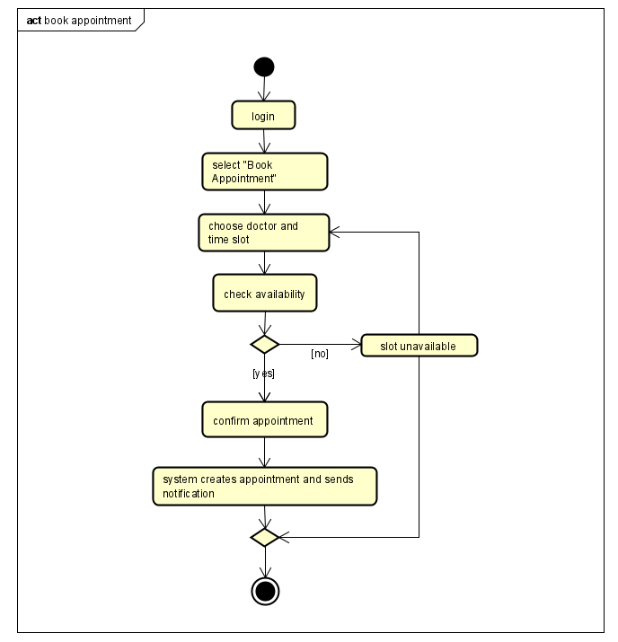

Manage Appointments (Staff member)
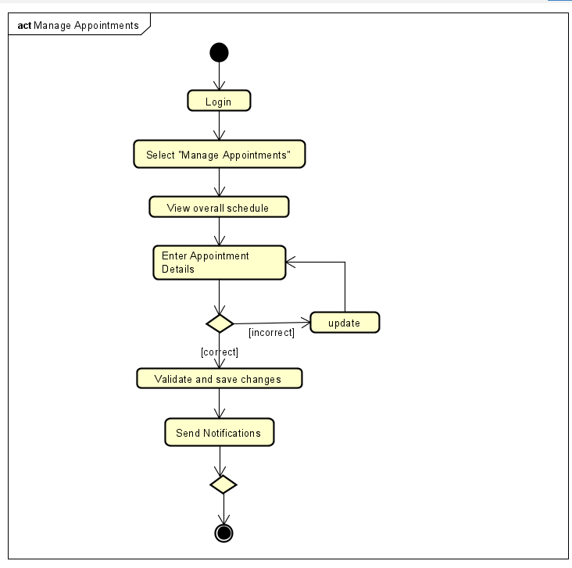

Domain Model
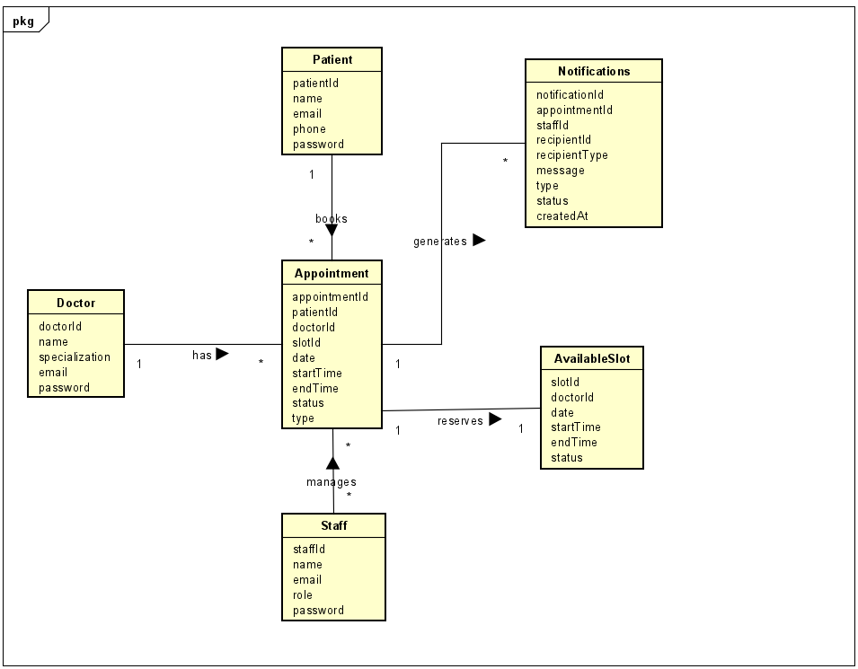

EER DIAGRAM
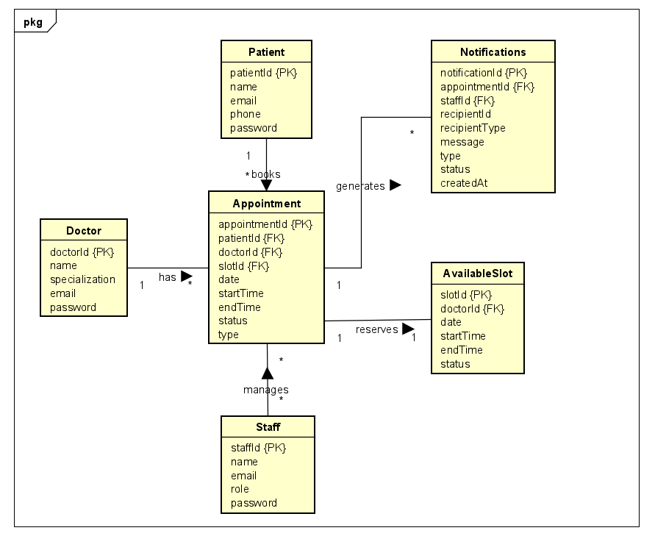

Entity Class Diagram
